|  |
| --- |
|  |
| QUALITY PET FOOD CONTROL LIMITED CASE STUDY |
|  |

**Contents page**

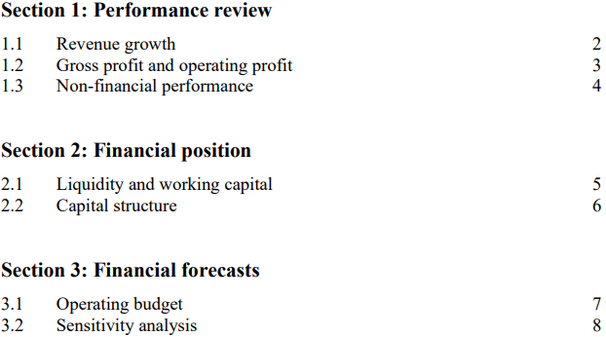

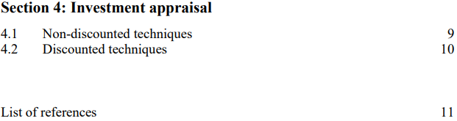

**Section 1: Performance review**

**1.1 Revenue growth**

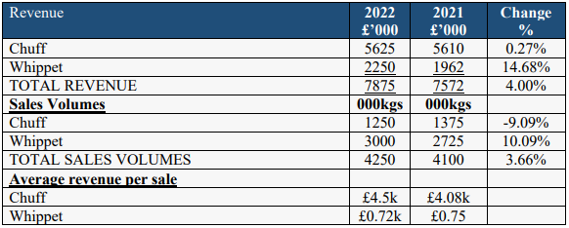

Table 1: Revenue Growth for Quality Pet Food

Quality Pet Food Limited initially produced Chuff pet food locally but transitioned to a purpose-built facility to meet growing demand, sourcing ingredients from local and international suppliers. They secured a contract with a national supermarket to produce Whippet pet food, although at a lower price point with a different recipe. To fund expansion and meet supermarket demand, they obtained a £2.5 million bank loan. This move saw both Chuff and Whippet sales increase steadily showcasing their balanced growth strategy and adaptation to market dynamics.

The company had to raise pricing because of inflation increases and supply-chain difficulties. The United Kingdom experienced a 9.4% inflation in June 2022, while the pet food business experienced 8.4% inflation, resulting in a fifteen percent rise in pet food costs in the United Kingdom from January to August 2022. The food supply chain business is currently dealing with issues like rising expenses for inputs, shipping, packaging costs, gas, and energy prices, among others (Research and Markets, 2022). Consumers' dissatisfaction, nevertheless, also limited their capacity to consent on all price increases. Despite these obstacles, the business was still able to expand its overall revenue, a sign of successful marketing tactics and consumer demand.

The U.K. pet food industry had a value of $6.0 billion in 2021 and is projected to keep growing at a CAGR of 3.0% from 2022 to 2027 (Research and Markets, 2022).Quality Pet Food company revenue for Chuff and Whippet pet food grown at 4.0% during the period of 2021 to 2022, this was more than the pet food market industry analysis of 3%. This is due to the fact that pet owners are beginning to treat their animals more like people by paying close attention to their food and health, which has greatly boosted the industry. One of the item lines being produced as an effect of a movement toward "humanizing" pet foods is pet food with ingredients, texture, and a presentation similar to human meals. Regardless of cost, pet owners are increasingly opting for high-quality pet food for feeding their pets.The tendency toward humanization has increased the popularity of premium pet food. The need for premium pet food alternatives has risen as a consequence of premiumization. These include gourmet, homemade, clean-label, prepared with components that are harvested locally, which include significant protein, vegetables, and other healthy ingredients (Research and Markets, 2022).

**1.2 Gross profit and operating profit**

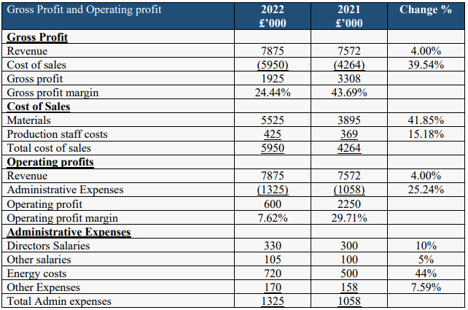

Table 2: Quality Pet Food's Gross Profit and Operating Profit

To meet the growing demand for Whippet from the national supermarket chain, the company increased production capacity. This involves higher production staff costs, materials costs, energy costs and other operational expenses, contributing to the overall increase in the cost of sales. The company started buying quality fresh meat and fish from local farms and fisheries, as well as grain from international food importers. Changes in the cost of raw materials, such as fluctuations in grain prices, impacts the cost of sales which increased from 4,264,000 to 5,950,000.

To cover increased production expenses, the business had to raise the price of sale prices. Nevertheless, clients' objections prevented it from passing on all of its price increases. This defiance most likely had an impact on the gross profit margin (which decreased from 43.69% to 24.44%) by lowering the profitability of the sales. Furthermore, there is a continual rise in the cost of grain, which is utilized in all of the organization's pet food items. This is a significant component of the cost of sales. The rising grain prices directly impacted the cost of sales, potentially reducing the gross profit margin.

The Pet Food Manufacturers Association explains the reason for the increasing expenses of pet food production by drawing parallels between the pet food industry and the food sector, which both operate in unstable environments and deal with increasing expenses for ingredients, energy, transport, and packaging as a result of global occurrences (Perrett, 2022). Although there are numerous trends in the market, including raw food programs and plant-based foods, a lot of these goods are in the top tier of the premium market, which drives up the overall price of production (Cappato, 2023).

**1.3 non-financial performance**

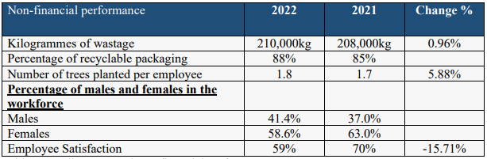

Table 3: Quality Pet Food non-financial performance

The significant drop in employee satisfaction from 70% in 2021 to 59% in 2022 could be attributed the challenges faced by the company, including cost pressures and supply chain issues, which led to increased workloads and stress. Additionally, Independent stores, which are key customers for the company, faced cash flow difficulties due to slower sales. This had a trickle-down effect on the company's finances and potentially its ability to provide raises or bonuses to employees, further impacting satisfaction.

Employee satisfaction within Quality Pet Foods Limited, as indicated by the provided table, can be assessed through the Internal Process Perspective of the Balanced Scorecard framework. From the Internal Process Perspective, it is evident that employee satisfaction has a direct impact on the company's internal processes (Kaplan, 2021). The strategic review highlights that the company faced challenges in 2022, including inflationary pressures and supply-chain disruptions. These challenges put increased pressure on employees to adapt and cope with changing conditions. Satisfied employees tend to be more engaged and motivated, positively affecting the efficiency of internal processes (Zhenjing et al., 2022). Despite external challenges, if employees remain content, they are more likely to maintain productivity and uphold established processes effectively. Additionally, employee satisfaction can influence how well employees handle unexpected challenges. A workforce that feels supported and valued is more likely to adapt to disruptions, find creative solutions to problems, and continue to contribute positively to the organization's processes (Zhenjing et al., 2022).

**Section 2: Financial position**

**2.1 Liquidity and working capital**

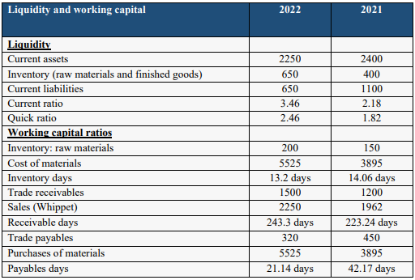

Table 4: Liquidity and working capital for Quality Pet Foods

The company experience a fall in inventory days from 2021 to 2022, due to rising costs, the company adopted a more efficient inventory management approach to reduce carrying costs associated with higher-priced raw materials and finished goods. This could include better demand forecasting and a leaner production process, leading to a decrease in inventory days. Additionally, the company ongoing increase in the price of grain, a key ingredient in the company's pet food products was another reason. To manage this cost challenge, the company's strategic response included minimizing excess grain inventory and efficiently using available grain resources, leading to a reduction in inventory days. The increase in receivable days can be attributed to customer payment challenges. A number of independent stores, which are among the company's customers, experienced slower sales and cash flow difficulties during the year. This situation likely led to delays in customers' payment cycles. When customers face financial challenges, they may take longer to pay their invoices, resulting in an increase in receivable days.

Effective working capital management holds paramount importance in family businesses like quality pet food. These enterprises, driven by a commitment to multi-generational survival, rely on sound working capital practices to fortify their financial stability. This stability enables them to navigate economic uncertainties, adapt to dynamic market conditions, and endure unforeseen challenges, ensuring the company's continued existence (Sah et al., 2022). Simultaneously, family firms highly value their reputation, deeply rooted in local communities and customer relationships. A well-structured working capital management strategy serves as a linchpin in safeguarding this reputation by facilitating the fulfillment of commitments, timely financial obligations, and the sustenance of trust and goodwill (Sah et al., 2022). As reputation is pivotal to family businesses, the preservation of this invaluable asset becomes an overarching concern, emphasizing the indispensability of working capital management in these enterprises.

**2.2 Capital structure**

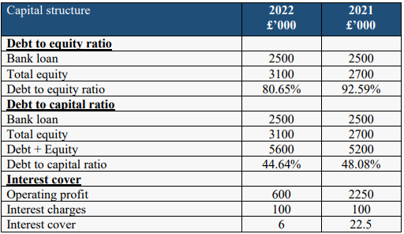

Table 5: Capital structure

The decrease in the Debt-to-Equity Ratio (D/E), Debt to Capital Ratio, and Interest Cover for Quality Pet Food Limited can be explained by several factors stemming from the company's strategic developments and financial management. Quality Pet Food obtained a £2.5 million bank loan to fund its expansion in response to the contract with the national supermarket chain for Whippet dog food. The bank loan carries a fixed interest rate of 4% per annum and is due to be repaid in December 2028. As the company is gradually repaying this loan, it reduces its total debt, leading to a decrease in both the Debt-to-Equity Ratio and Debt to Capital Ratio. This debt reduction is a positive sign as it lowers the company's financial leverage. According to traditional capital structure theory, a lower D/E ratio is generally considered less risky (Khan, 2021). It signifies a balanced capital structure with less reliance on debt, reducing financial distress risk. In Quality Pet Food's case, the decrease in the D/E indicates a move towards a more balanced capital structure with relatively less debt funding.

The significant decline in Quality Pet Food's Interest Cover from 22.5 in 2021 to 6 in 2022 highlights potential challenges in meeting interest expenses. A decrease in interest cover suggests that the company's operating profit may have decreased relative to its interest charges (Maverick, 2023). Several factors could contribute to this decline, including increased operating costs associated with expansion and potentially reduced profitability due to the introduction of the Whippet contract. The lower-priced Whippet product with a different recipe may have a narrower profit margin compared to Chuff, impacting the company's ability to generate sufficient operating profit to cover its interest obligations. It is crucial for Quality Pet Food to address these profitability concerns to ensure its long-term financial stability and ability to meet its financial commitments.

**Section 3: Financial forecasts**

**3.1 Operating budget**

|  |  |  |
| --- | --- | --- |
| Operating budget 2023 | **Chuff (2023)** | **Whippet (2023)** |
| Sales Volume | 1437.5 kg | 3600 kg |
|  | **Chuff £’000 (2023) + Whippet £’000 (2023)** | |
| Revenue | 10912.5 | |
| Cost of Materials | 6077.5 | |
| Production Labour | 429.3 | |
| Gross profit | 4405.7 | |
| Admin Expenses | 1430.8 | |
| Operating profit | 2974.9 | |
| Gross profit margins | 40.4% | |
| Operating profit margins | 27.3% | |

Table 6: Operating Budget

The above incremental operating budget is based on the actual financial results from the year ended 31 December 2022, with adjustments and assumptions made by the directors. Incremental budget considers the actual financial results from the previous year and incorporates adjustments and assumptions for the upcoming year. It reflects the company's strategic response to cost challenges, market conditions, and its efforts to maintain profitability and address cash flow concerns.

The forecasted increase in sales volumes for Chuff and Whippet in 2023 aligns with the company's strategic response to address the challenges such as inflation and resistance from customers. Despite facing resistance from customers due to price increases in the previous year, the company remains committed to sales growth. This suggests that the company aims to overcome pricing challenges by focusing on volume growth. The strategic review highlights cost pressures due to inflation and supply-chain challenges. Pet food manufacturers can mitigate supply-chain disruptions through proactive planning and cost-effective sourcing (Gibeson, 2022). The detailed cost estimates for materials and production labour in the budget demonstrate the company's commitment to cost management strategies, aligning with industry best practices.

Maintaining healthy profit margins is crucial for pet food manufacturers. Industry benchmarks show that successful companies often achieve gross profit margins above 40% (Tortora, 2023). Quality Pet Food's target gross profit margin of 40.4% aligns with industry standards and indicates its determination to remain competitive. The projected operating profit margin of 27.3% reflects the company's strategic efforts to balance profitability with cost control, a practice emphasized in leading pet food manufacturing firms (Malnight, 2019).

**3.2 Sensitivity analysis**

|  |  |  |
| --- | --- | --- |
| **Sensitivity analysis** | **2023** | **2022** |
| Revenue | 10912.5 | 7875 |
| Cost of Materials | 6077.5 | 5525 |
| Production Labor | 429.3 | 425 |
| Gross profit | 4405.7 | 1925 |
| Admin Expenses | 1430.8 | 1325 |
| Budgeted profit | 2974.9 |  |
| Sensitivity of revenue | 27.3% |  |

Table 7: Sensitivity Analysis

The sensitivity assumptions were provided by the board of directors, commonly referred to as an imposed budget, serve as a financial plan that outlines expected revenues and expenses for the fiscal year. However, these sensitivity assumptions are not static and can be influenced by various factors, including changes in market conditions and performance. This sensitivity to external factors is an inherent characteristic of budgets, and it's important to recognize the potential impact on actual results. Operating budget for 2023 reflect the company's response to a challenging business environment in 2022. The directors acknowledged the significant difficulties faced by Quality Pet Food Limited (Quality Pet Food) during the year, including rising costs due to inflationary pressures and supply-chain challenges.

Changes in market conditions, such as shifts in consumer preferences, fluctuations in demand for pet food products, or changes in pricing dynamics, can significantly affect the actual results compared to the sensitivity assumptions. For instance, if there is an unexpected increase in demand for premium pet food products (Chuff and Whippet), it could lead to higher revenues exceeding the assumed budget of £10,912.5 thousand. Conversely, adverse market conditions, such as increased competition or economic downturns, might result in lower-than-expected revenues (Mussa, 2015). Performance-related factors, such as production efficiencies and cost management, also play a crucial role. If the company efficiently manages its cost of materials and production labour, it could improve gross profit margins and ultimately budgeted profits.

Sensitivity analysis is a valuable tool to assess the flexibility and robustness of a budget. It helps identify whether the sensitivity assumptions were influenced by budget slack or upward bias, which are common types of budgetary biases. Budget slack occurs when managers intentionally underestimate revenues or overestimate expenses to make it easier to achieve their budgeted targets (Mohanna and Sponem, 2020). This can hinder performance and negatively impact financial outcomes. On the other hand, upward bias involves setting overly optimistic revenue projections or underestimating expenses, which can lead to unrealistic budget expectations (Martinez, 2002). In the case of Quality Pet Food Limited's sensitivity analysis, if the assumed figures show a significant deviation from actual results due to market conditions or performance, it may indicate that the budget was affected by either budget slack or upward bias.

**Section 4: Investment appraisal**

**4.1 non-discounted techniques**

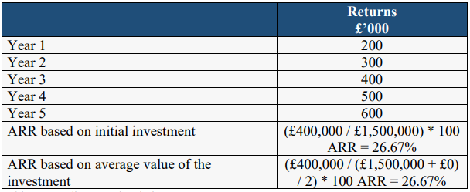

Table 8: non-discounted techniques

The grain-free pet food investment is expected to generate positive returns over the five-year period. The Account Rate of Return (ARR) indicates a profitability of 26.67% based on both the initial investment and the average value of the investment. However, these calculations fall short of the board's specified targets. The ARR based on the initial investment is 26.67%, which is below the 30% target, and the ARR based on the average value of the investment is also 26.67%, missing the 60% target. However, it's important to note that these calculations do not consider the time value of money, the payback period requirement, or the company's cost of capital. To conduct a more comprehensive investment appraisal, discounted cash flow techniques like Net Present Value (NPV) should be used to assess profitability while considering these additional factors. Additionally, a thorough risk assessment should be conducted to evaluate market conditions and other potential uncertainties that could impact the investment's outcomes.

While non-discounted techniques such as ARR provide a basic assessment of profitability, they have limitations in capturing the full financial implications and risks associated with an investment (EduPristine, 2021). Non-discounted techniques, offer simplicity and ease of understanding, making them accessible for quick initial investment assessments. However, their simplicity comes with limitations. While they can be useful for comparing projects of similar size and duration, they ignore the time value of money, failing to consider that a pound today is worth more than a pound in the future. Additionally, ARR techniques focus on accounting profits, providing insights into short-term financial performance but incomplete assessments of long-term implications, including opportunity costs and risks (Chron, 2020). Thus, they may not offer clear guidance on whether an investment meets required profitability and return criteria.

**4.2 Discounted techniques**

|  |  |  |
| --- | --- | --- |
| Year | **Cash flow £’000** | **Discounted Cash flow £’000** |
| 0 | -1500 | -1500 |
| 1 | 200 | 188.679 |
| 2 | 300 | 265.720 |
| 3 | 400 | 334.715 |
| 4 | 500 | 396.575 |
| 5 | 600 | 451.217 |
| Net Present Value (NPV) | NPV = (£188,679 + £265,720 + £334,715 + £396,575 + £451,217) - £1,500,000= £1,037,906 | |

Table 9: Discounted technique

The discounted techniques reveal important insights into the grain-free pet food investment's financial viability. The Net Present Value (NPV) is a key indicator, and it stands at £1,037,906. This positive NPV suggests that the investment has the potential to generate returns higher than the initial outlay of £1,500,000. In financial terms, a positive NPV suggests that the investment is likely to add value to the company and contribute positively to its financial position. It signifies that the expected cash inflows, represented by the annual returns over the five-year period, are substantial enough to cover not only the initial investment but also generate an additional £1,037,906 in present value terms.

This outcome aligns with the board of directors' objective of achieving a positive NPV for the investment. A positive NPV implies that the investment is economically viable and capable of providing a return that surpasses the company's cost of capital, which was calculated at 6% per annum. Consequently, the grain-free pet food investment appears to meet the company's financial criteria, as it demonstrates the potential for wealth creation and increased shareholder value.

Discounted techniques like the Net Present Value (NPV) provide a comprehensive assessment of investment value, aiding informed resource allocation and wealth maximization (Gaille, 2020). They consider cash flows' magnitude and timing, aligning with financial goals. However, their reliance on accurate cash flow forecasts poses a risk of distorted results. Subjective discount rates introduce bias, and these methods may overlook qualitative factors vital to investment decisions (Fool, 2015).

**References**

Cappato, T. (2023) *How Inflation is Impacting Pet Food Products in Europe*. Euromonitor. [Online] https://www.euromonitor.com/article/how-inflation-is-impacting-pet-food-products-in-europe.

Chron (2020) *The Pros &amp; Cons of the Average Accounting Return Method*. Small Business - Chron.com. [Online] [Accessed September 15th, 2023] https://smallbusiness.chron.com/pros-cons-average-accounting-return-method-34428.html.

EduPristine (2021) *Capital Budgeting Techniques, Importance and Example*. EduPristine. [Online] [Accessed September 15th, 2023] https://www.edupristine.com/blog/capital-budgeting-techniques.

Fool, M. (2015) *Advantages and Disadvantages of Net Present Value Method*. Nasdaq. [Online] https://www.nasdaq.com/articles/advantages-and-disadvantages-net-present-value-method-2015-11-14.

Gaille, L. (2020) *19 Advantages and Disadvantages of Net Present Value*. [Online] https://vittana.org/19-advantages-and-disadvantages-of-net-present-value.

Gibeson, A. (2022) *Navigating the ever-changing supply chain*. /images/favicons/. [Online] https://www.petfoodprocessing.net/articles/15794-navigating-the-ever-changing-supply-chain.

Kaplan, R. S. (2021) *The Balanced Scorecard—Measures that Drive Performance*. Harvard Business Review. [Online] https://hbr.org/1992/01/the-balanced-scorecard-measures-that-drive-performance-2.

Khan, M. A. (2021) “Capital Structure Theories: A Comprehensive Review.” *Revista Gestão Inovação e Tecnologias*. Centivens Institute of Innovative Research, 11(3) pp. 1562–1574.

Malnight, T. W. (2019) *Put Purpose at the Core of Your Strategy*. Harvard Business Review. [Online] https://hbr.org/2019/09/put-purpose-at-the-core-of-your-strategy.

Martinez, M. (2002) *The Effects of Budget-Based Incentive Compensation*. [Online] [Accessed September 15th, 2023] https://maaw.info/ArticleSummaries/ArtSumWalkerJohnson99.htm.

Maverick, J. B. (2023) *Interest Coverage Ratio (ICR): What’s Considered a Good Number?* Investopedia. [Online] [Accessed September 15th, 2023] https://www.investopedia.com/ask/answers/121814/what-good-interest-coverage-ratio.asp#:~:text=A%20low%2Dinterest%20coverage%20ratio%20means%20there%20is%20a%20low,available%20to%20service%20the%20debt.

Mohanna, D. and Sponem, S. (2020) “The impact of the budget process on budgetary slack: The moderating role of uncertainty avoidance and individualism.” *Comptabilité Contrôle Audit*. CAIRN, Tome 26(2) pp. 45–87.

Mussa, M. (2015) *Factors Driving Global Economic Integration -- by Michael Mussa, Economic Counselor and Director of Research, IMF*. IMF. [Online] [Accessed September 15th, 2023] https://www.imf.org/en/News/Articles/2015/09/28/04/53/sp082500.

Perrett, M. (2022) *Pet food: How is the cost-of-living crisis and global supply chains impacting manufacturers?* foodmanufacture.co.uk. [Online] [Accessed September 15th, 2023] https://www.foodmanufacture.co.uk/Article/2022/11/11/Pet-food-How-is-the-cost-of-living-crisis-and-global-supply-chains-impacting-manufacturers.

Research and Markets (2022) *U.K. Pet Food Market- Size, Trends, Competitive Analysis and Forecasts (2022-2027)*. Research and Markets ltd 2023. [Online] [Accessed September 14th, 2023] https://www.researchandmarkets.com/reports/5668864/u-k-pet-food-market-size-trends-competitive#:~:text=The%20pet%20food%20market%20in,the%20period%202022%20to%202027.

Sah, N. B., Banerjee, A., Malm, J. and Rahman, A. (2022) “A good name is better than riches: Family firms and working capital management.” *Journal of Behavioral and Experimental Finance*. Elsevier BV, 33, March, p. 100599.

Tortora, M. (2023) *Revenue Growth & The Importance of Gross Profit Margin*. www.linkedin.com. [Online] [Accessed September 15th, 2023] https://www.linkedin.com/pulse/revenue-growth-importance-gross-profit-margin-matt-tortora.

Zhenjing, G., Chupradit, S., Ku, K. Y., Nassani, A. A. and Haffar, M. (2022) “Impact of Employees’ Workplace Environment on Employees’ Performance: A Multi-Mediation Model.” *Frontiers in Public Health*. Frontiers Media SA, 10, May.