**LEADERSHIP DEVELOPMENT**

Contents

LEADERSHIP DEVELOPMENT 3

INTRODUCTION 3

1. A CRITIQUE OF LEADERSHIP THEORY LEARNED THROUGHOUT THE MODULE. 3

2. EVALUATION OF THE PROBLEM BASED EVENT 7

3. AUDIT OF OWN STRENGTH AND WEAKNESS AS A LEADER 10

4. PERSONAL LEADERSHIP DEVELOPMENT PLAN 12

CONCLUSION 14

REFERENCE 15

Appendices 18

Appendix 1 18

## INTRODUCTION

This report will address four issues. The first will illustrate the theoretical basis for the crucial part that followership serves in the leadership function. Utilizing the Toxic Triangle2 of Destructive Leadership2 at Bristol Royal2 Infirmary: A Study2 of Organizational2 Munchausen Syndrome2 by Proxy, which we covered in this session, will come after that. Second, an assessment of a problem-based activity will be carried out, with the emphasis on a challenge related to a group business plan that was set in this unit. Analyzing my performance and interactions with my coworkers will help me focus on the aspects where I have thrived and how I can gradually build others. Thirdly, I've conducted an audit of my own leadership abilities and flaws using a variety of techniques. My understanding of essential personal capabilities has been greatly heightened by a focus on core leadership qualities including problem solving, communication2, and addressing conflict. The last section discusses how to create a customized leadership development2 strategy. This report was written predicated on problems that require fixing that appeared in other portions of this report. One of the key goals is to boost self-confidence and lessen self-criticism. The program created will be the most feasible for me to carry out, and as a consequence, it should assist me in quickly improve my leadership abilities. The development duties are more focused on the individual than they are on leadership.

## 1. A CRITIQUE OF LEADERSHIP THEORY LEARNED THROUGHOUT THE MODULE.

Leadership theory is a complex and multifaceted field that has been studied and debated for decades. The key concepts and theories of leadership in organizations have evolved over time, and there are a number of different perspectives and approaches that have been developed. While there have been many valuable insights and contributions made in this area, there are also a number of critiques and limitations that have been identified (Harrison, 2017, p.16).

This subsection will emphasize the value of effective leadership and the significance of followership. With the aid of the case study Bristol Royal2 Infirmary: A Study of Organizational2 Munchausen Syndrome2 by Proxy by Fraher (2014, p. 34), it will be easier to understand how destructive leaders contribute to the construction of the toxic triangle by aligning themselves with vulnerable subordinates and supportive environments.

Although there have not been as many research on followership as there have been on leadership, their significance in the leadership practice cannot be denied. Famous social scientist Robert E. Kelly (1993, p. 227) examined the behaviors that produce effective and ineffective followership and identified two underlying behavioral aspects that contribute to the explanation of the distinction. The extent to which followers engage in autonomous, critical thought is measured by one dimension. The other rates them on a scale of inactive2 to active2. Critical thinkers and engaged followers are committed fully in the leadership approach and offer the leadership constructive feedback. Conversely, inactive uncritical thinkers adopt a more "hands off" style and only become involved in the leadership procedure when requested to. According to Kelley (1993), there are five different types of followership: passive2, conformist, alienated2, pragmatist, and exemplary2.

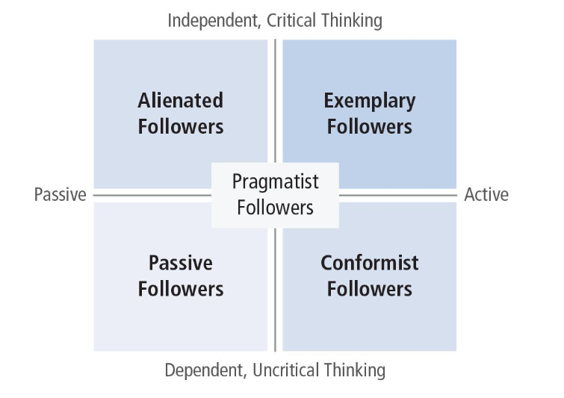

Figure 1: Kelly Follower Typology (1993)

Kelly's typology is intended to help leaders understand and manage the different types of followers they may encounter, and to adapt their leadership style to better meet the needs and expectations of different followers.

According to figure 1, those who are unquestioning and docile in their followership are known as passive followers, or "sheep." They lack innovation and are more likely to concentrate solely on finishing the work at hand. The followers of conformists are often more engaged, but they are also like 'passive following' in that they look on the leadership to encourage and push them. Since they very gladly engage in the leadership effort yet don't challenge directives, they are frequently referred to as "yes men." This sort of follower might be an issue when the leadership is acting immorally or making poor decisions. Even if they may differ with the leadership, followers tend to keep their disagreements to themselves in order to maintain good relations with the leadership and prevent confrontation (Hinojosa et al., 2014, p. 595).

Pragmatists (survivors) fall somewhere between the autonomous, critical thinking/dependent2, uncritical thinking2 scale and the passive/active2 scale. They are often called to as "fence sitters" as a result. Since they like to take the safe route, they frequently accept the perspective of the mass and alternate between various sorts of followership as circumstances call for. Autonomous and critical thinkers by nature, alienated followers have lost their drive to actively play their part for some circumstance. They have something to contribute, yet they are frequently pessimistic and skeptical, making it challenging to inspire them. This particular kind of follower is typically the greatest disrupting of the five (Cooper, 2003, p.175).

In comparison to other kind of followers, star/exemplary adherents have greater enthusiasm and committed to finish their given assignment, going above and beyond, pushing boundaries, and being capable to perform even without clear instructions from the leadership. These kinds of followers are remarkably beneficial to organizations and, as per Kelly (1993), they are undoubtedly just as beneficial as leading figures themselves. Kelly (1993) argues that in a group of Star followers, an institution doesn't necessarily require a leader but rather a supervisor because there isn't a necessity for a recommended direction because typical leadership doesn't take place.

For instance, consider the Bristol Royal Infirmary (BRI) controversy, which entailed subpar treatment and high rates of death at the hospital's cardiac surgery unit and was made public in the late 1990s. A toxic2 triangle (Figure2 2) is constructed to highlight for all the factors toxic leadership has a structural impact instead of condemning a damaging or toxic scenario, institution, or situation on the leadership in the middle (Fraher, 2014, p. 34).

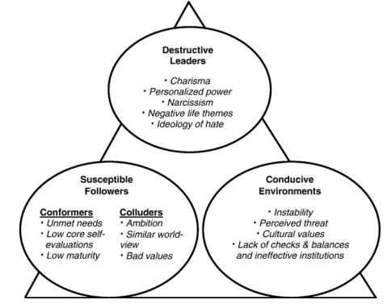

Figure 2: The2 Toxic Triangle2: Elements2 in Three2 Domains Related2 to Destructive2 Leadership

The Bristol Royal Infirmary (BRI) case is a well-known example of destructive leadership in practice. The case, which came to light in the late 1990s, involved a series of scandals related to poor care and high mortality rates at the hospital's pediatric cardiac unit. An inquiry led by Sir Ian Kennedy revealed that a toxic triangle of destructive leadership was at the root of the problems at BRI (Fraher, 2014, p. 34).

In the instance of Bristol Royal Infirmary, the issue was readily extended to the followers in addition to an environment that encouraged improper conduct. The issue was not limited to a strong figure who utilized radical ideals to win people over to his agenda. The first element of the toxic triangle was a culture of fear and bullying, which was fostered by the unit's clinical director, James Wisheart. Wisheart was described as an autocratic leader who ruled by fear, and who tolerated no dissent or criticism (Kennedy, 2007). Staff that raised concerns about poor care or high mortality rates were bullied, harassed, and intimidated. This created a culture of silence and defensiveness, in which staff were afraid to speak up or take action to address the problems.

The second element of the toxic triangle was a lack of accountability and transparency. Wisheart and other senior leaders at BRI failed to take responsibility for the problems at the unit, and instead tried to blame others or deflect blame. They also failed to provide accurate or complete information about the unit's performance or outcomes, which made it difficult for staff, patients, or regulators to identify or address the problems (Edmonds, 2021, p. 47).

The third element of the toxic triangle was a lack of clinical governance and oversight (Grummert & Rall, 2021, p. 35). Wisheart and other senior leaders at BRI failed to establish and maintain effective systems and processes for monitoring and improving the quality and safety of care at the unit. They also failed to provide appropriate training, support, or supervision to staff, which led to poor care practices and high mortality rates.

The toxic triangle of destructive leadership at BRI ultimately led to poor care and high mortality rates for patients, as well as significant harm and trauma for staff. The case highlights the importance of effective leadership, clinical governance, and oversight in ensuring the quality and safety of healthcare. It also illustrates the destructive consequences of a culture of fear and bullying, lack of accountability and transparency, and lack of clinical governance and oversight (Schyns et al., 2022, p. 253).

## 2. EVALUATION OF THE PROBLEM BASED EVENT

This sub-section will assess the problem-based task that was completed as a part of this class. Figure 3 depicts the project's requirements and the real-world business scenario we opted for as a group. It will detail my particular tasks and the manner in which I worked with my colleagues.

|  |
| --- |
| Business plan targeting the University of Lincoln international students |
| Characteristic of service: distribute foreign food for international students |
| Marketing is to be done through social media, word of mouth and through student union |

Figure 3: project brief

For this task we were instructed to work as a team. Nonetheless, teams are complex and when new members are added to a team, the dynamics of the team can change. The addition of new members can bring fresh perspectives and ideas, but it can also disrupt the existing team dynamics and communication patterns. The team may need to adjust to the new member's communication style and work habits, and the new member may need time to understand and adapt to the team's established norms and processes. The team may need to revisit and redefine their goals and roles to include the new member. The team leader may need to pay attention to the team dynamics and actively work to integrate the new member into the team and help the team to adjust to the change. For group formation we went through the stages of Tuckman’s stages of group development (Tuckman, 1965).

I automatically assumed the role of leader for this endeavor, and as one of the group's initial founding members, my ties with other group members played a role in this. I've gotten along well with several members of the group and assisted them out, thus building trust. I immediately adopted the democratic leadership style to help the group avid falling into the groupthink mentality (When people adopt the standard instead of thinking for themselves, it is known as groupthink) (Modeste, 2022, p. 87).

Democratic leadership can help prevent groupthink in a group by promoting an environment of open communication, active participation, and diversity of perspectives. Democratic leaders encourage members to share their ideas and opinions and actively listen to and consider the contributions of all members. This can prevent the formation of a dominant group mindset and help to identify and address potential problems early on. I believe in the end a functional group was created (Kane et al., 2009, p. 9).

It was essential that we create a strong working relationship. Maslow's2 hierarchy2 of needs (Figure2 4) shows how important it is for people to feel a sense of love and belonging and to have their physiological needs met (Maslow, A. 1943).

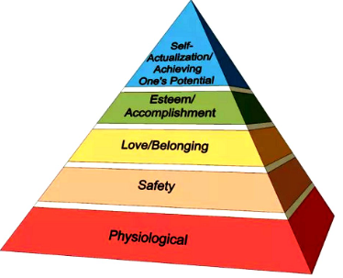

Figure 4: Maslow's Hierarchy of Needs

I believe that the group's capacity to satiate their needs for love and belonging was a determining factor in whether they were able to effectively finish this exercise. Since it could motivate someone to strive more, it can be argued that it is both a psychological desire and a basic want. According to Maslow's hierarchy of needs from 1943, people are motivated to meet particular wants, and neglecting to recognize needs can cause pain or even cause people to regress (Maslow, A. 1943). Our basic desires are for existence, safety, affiliation, status, and self-actualization, based on this material notion of motivation, and we only pursue higher-order desires when our basic needs have been satisfied. Therefore, even though we wanted to feel at ease around each other, the possibility of meeting that need had an effect on how well our team worked together psychologically. I think that my style of leadership helped to develop the psychological security of the group (Bowen, 2020, p. 45).

For this, I used a democratic method, which encourages a cooperative, task-focused, and group-centered environment where productivity is still fairly high even in the absence of the leadership (Buchanan and Huczynski, 2017, p.368). Additionally, this style of leadership and psychological requirements has a favorable association (Fields, 2008, p. 272). By adopting this strategy, all members of the team were allowed to express their ideas and thoughts, which allowed us to collaborate more effectively and produce the greatest results.

My personality type was another aspect of my leadership that had a favorable effect on the psychological stability of my team. We took the Myers-Briggs2 personality type indicator and all group members—with the exception of one—were introverted2, sensing, thinking, and prospecting2, based on the results (Myers-Briggs, 2022). It might be claimed that extroverts make better leadership even though I am an introvert. As a consequence, assigning appropriate roles based on personality characteristics may be useful in the long term. I believe I was a good match for the leadership role despite the fact that there may have been a theoretically superior candidate due to my emotional development in identifying the group's requirements one issue that would have been troublesome was ensuring dominating personality types2 couldn't possibly overwhelm the team's beliefs and judgment call. Prior to now, I was a little unaware of them and could have easily fallen victim to groupthink. However, the module's material made it possible for me to be conscious of this and make sure that I sought to stop it prior to it becoming a problem. I believe that this issue may recur in the future under a range of scenarios, which I can already predict.

The subjects we discussed will have equipped me with useful expertise that I can use in my roles as a member of the team and in leadership or management in the future. Despite the fact that I believe I have a strong leadership aesthetic based on my previous experience, there is always space for development.

## 3. AUDIT OF OWN STRENGTH AND WEAKNESS AS A LEADER

With the help of this module, I was able to identify my personal leadership qualities, and this subsection will assess my strengths and weaknesses in that respect. The subsequent section will then build on them to demonstrate how I can grow. These will be examined in more depth. The figure below (Figure 5) lists my primary strengths and weaknesses.

|  |  |
| --- | --- |
| **STRENGTH** | **WEAKNESS** |
| Trustworthy | Lack of Self-confident |
| Friendly | Poor communicator |
| Problem solving | Highly self-critical |
| Sensitive | Less firm/authoritative |
| Diligent |  |

Figure 5

I filled in a leadership trait questionnaire provided by this module in order to find out about my leadership capabilities. Leadership traits refer to the innate characteristics or qualities that a person possesses and that influence their ability to lead effectively. These traits can be related to personality, behavior, and mindset, and are thought to be relatively stable over time and across situations. After completion of the Leadership trait questionnaire (Appendix 1), I was able to pinpoint my strengths and weaknesses in terms of leadership. I was equipped to recognize some of my biggest shortcomings. My lack of perseverance, dearth of confidence, and harsh self-criticism are a few of these. I can govern people, but I lack the confidence to guide them in the most productive direction. I received a score of 59, which indicates that I am good holistically (the maximum score being 70). Yet there are areas for me to work on.

Another test I took was the Belbin Team Role Questionnaire. The Belbin Team Role Questionnaire is a tool for assessing an individual's preferred behavior and strengths in a team setting. It was developed by Dr. Meredith Belbin, a British researcher, and is based on the idea that successful teams are made up of individuals with a variety of different strengths and behaviors that complement each other (Belbin, 2022). The Belbin Team Role Questionnaire consists of a self-perception inventory and an observer assessment. It can be used to identify an individual's strengths and weaknesses in a team setting, to evaluate how well a team is functioning, and to identify areas where a team may need improvement. It can be used for selecting teams, developing teams, and also for personal development by identifying areas to work on in order to improve one's effectiveness in a team setting.

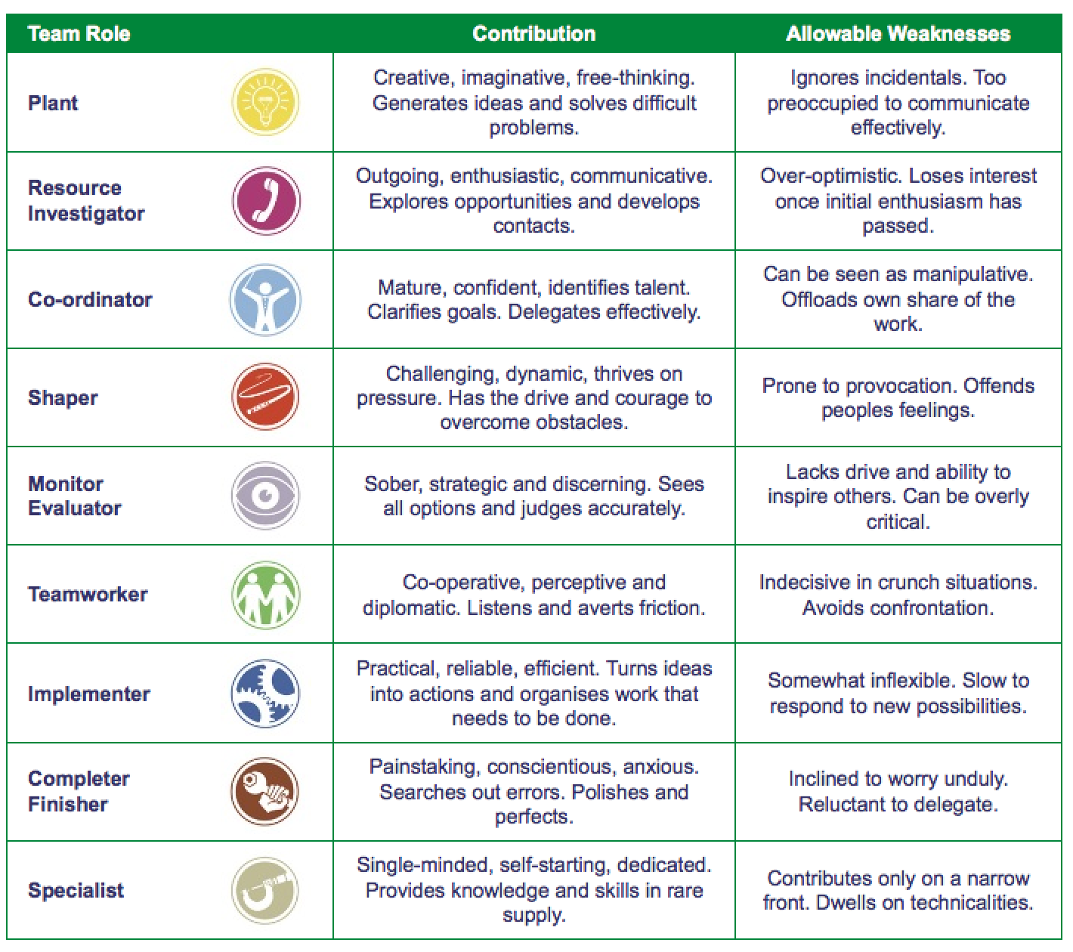

Figure 6: Belbin Team Role

When we reviewed the Belbin's2 team roles tool2 (Belbin, 2022), I found that I primarily fit into the plant, team worker2, and resource2 investigator categories (most of the group members did). We came to this conclusion after completing the Belbin's team roles tool that the team's strength, notwithstanding multiple disagreements involving members and poor communication due to members' diverse cultural backgrounds, was that we are people who enjoy tough work and problem-solving (Belbin, 2022). I think this is a skill we have, and it really helped me and others finish every assignment that was ours or was provided to us. Individual problem-solving abilities can be cultivated and strengthened by regularly conducting study, applying what is learned, continuing to learn, and exercising assiduously. One needs to use a range of techniques, as per Eisner, (2021). so that he may rapidly shift to another one if one fails. He may be able to choose the optimal approach as a result of this. It is crucial to employ and develop a problem-solving process that considers all personal qualities and perspectives.

Moreover, I filled the Thomas-Kilmann22 Conflict Mode2 Questionnaire2, and the findings are shown below2:

|  |  |
| --- | --- |
| Competing | Forcing : 3 |
| Collaborating | Problem solving : 8 |
| Compromising | Sharing :7 |
| Avoiding | Withdrawal: 8 |
| Withdrawing | Smoothing: 9 |

Figure 7

These findings show that I am more likely to avoid conflict and that I'm extremely collaborative while working to find a solution to an issue rather of taking an opposing stance (Thomas & Kilmann, 1974). These provide additional support for the team roles tool findings from Belbin. I agree that these results correctly reflect how I handle conflicts, but I hadn't really given it much attention before taking the survey. I still have a lot to learn about this because it has to do with my dearth of confidence. I will be more vulnerable to being taken advantage of in the future if I do not improve my capacity for handling conflict. After completing these assessments, I was able to identify my leadership attributes, which helped me to be more focused. In the next section, I'll discuss my plan of action for resolving the aspects where I know I can do better.

## 4. PERSONAL LEADERSHIP DEVELOPMENT PLAN

Based on the preceding section in which I identified my leadership shortcomings and capabilities, I have created a personal leadership2 development plan2 in order to be able to focus on the aspects that need the most effort. (Norton, 2019, p. 51). This program will be broken down into steps that cover the next timeframes of 0-63 months, 6-123 months, and 12-183 months to demonstrate how I will be able to demonstrate my growth in the areas I need to improve.

The primary goals I hope to achieve are to:

* Build Self-confident
* Improve communication skills
* Become more firm/authoritative
* Become less self-critical

**Phase 1: 0-6 months**

Essentially, having a great deal of self-doubt and feeling uneasy or insecure within myself is the root of the majority of my flaws. While being capable of putting up a front when necessary, particularly in workplace settings, in my private life, I frequently miss out on chances as a result of these problems.

Self-confidence is a vital trait of a successful leader. According to Locke & Latham (2002, p. 709), setting specific, challenging, and measurable goals can lead to improved self-efficacy and performance. In this phase, the focus will be on setting small, achievable goals and working towards achieving them. This will help to build a sense of accomplishment and boost self-confidence. Additionally, participating in public speaking opportunities, such as joining a local Toastmasters club or presenting in meetings, will also help to improve public speaking skills and build confidence, as outlined by Winatapura & Alek (2021, p. 5)

**Phase 2: 6-12 months**

Develop Self-awareness: According to Young (2021, p. 56), Self-awareness is the foundation of emotional intelligence, and it is the starting point for personal and professional growth. In this phase, the focus will be on developing self-awareness by practicing mindfulness and reflective journaling. This can include taking time to reflect on one's own behavior, emotions and thoughts, as well as seeking feedback from others, as outlined in "360-Degree Feedback and Self-Awareness" by Brett & Atwater (2001, p. 933).

**Phase 3: 12-18 months**

Practice assertiveness: Assertiveness is the ability to express one's own needs, wants and opinions in a clear and direct manner, without aggression or passivity. According to Chen & Silverthorne (2005, p. 282), assertiveness is a key skill for leaders and it can help to build self-confidence and improve relationships in the workplace. In this phase, the focus will be on practicing assertiveness by setting boundaries, expressing opinions and standing up for oneself.

Overall, I'm aware that this development program is about self-development than it is about leadership. I believe that by concentrating on these tasks, this program will help me tackle the attributes of my leadership approach that ought to be developed. As I gain more self-confidence2, it will be visible in all aspects of my life. It will increase both my confidence and the trust of my following in me as I make the choices I will need to as a leader (Banjeree, 2015, p. 9).

## CONCLUSION

As a conclusion, I now recognize my leadership style and know where I ought to make adjustments. By gaining a stronger theoretical2 understanding2 of the significance of followers and how they could influence a team's effectiveness, I have been equipped to use this in real-life circumstances as both a leade2r and a follower2. In the end, I've realized that developing my confidence is the most important ability I need to learn in order to grow into a more effective and capable leader. I believe that by developing a personalized leadership3 development plan, I will be capable of advancing personally in the future, which will be valuable for my career, enable me to participate in a multitude of scenarios more efficiently, and help others achieve more.

## 

## REFERENCE

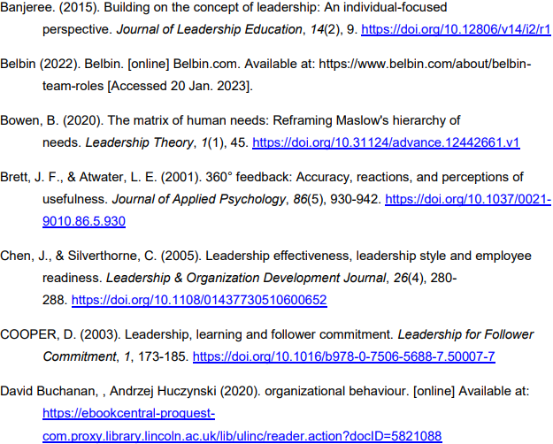

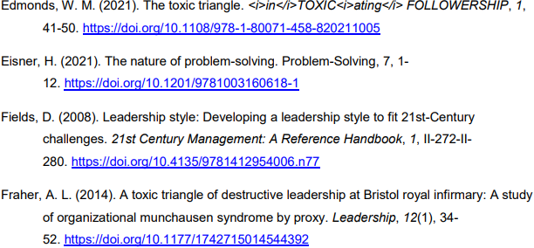

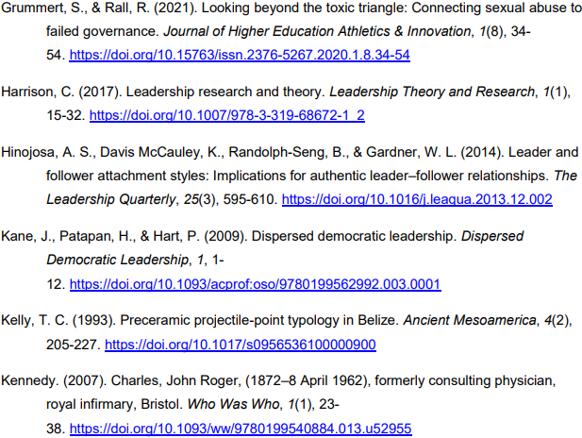

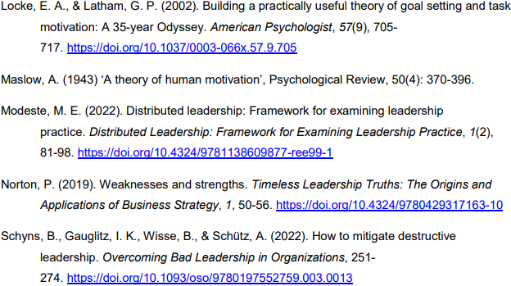

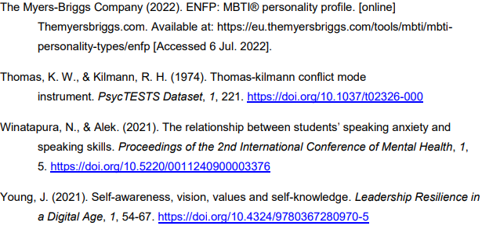

## Appendices

### Appendix 1

