

International Operations Strategy and Innovation

Case Study: “COCA COLA Company”



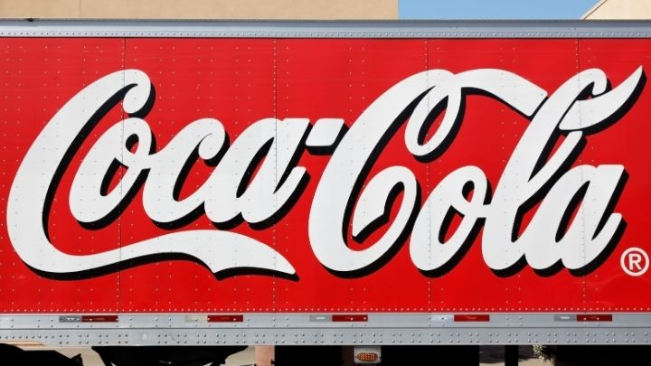

# Executive Summary

To succeed and expand, businesses of all stripes need to foster an innovation and creativity culture among their ranks. This would help them gain an advantage over rivals in the global market. Coca-Cola is a global company with locations all over the globe, thus this task is relevant to them. It is necessary to assess the methods the company use to foster and sustain a positive corporate culture. Organizations operating in a global economy have their own unique challenges, and their managers will need to come up with plans and techniques to overcome them. The company has an efficient supply chain that allows them to meet the demands of its consumers on time. They might get an advantage over rivals thanks to this. The project's goal is to assist Amazon achieve both their long- and short-term goals.

**Contents**

Executive Summary 1

1. Introduction 4

1.1. Competitors of COCA-COLA 5

1.2. PESTLE Analysis of Coca Cola 5

1.3. SWOT Analysis of Coca Cola 6

2. International Operations Management of Coca Cola 6

2.1. Information flow 8

2.2. Manufacturing process 8

2.3. Production Systems 8

2.4. Products 9

2.5. Total Quality Management (TQM) 10

2.6. Management of Coca Cola Inventory units: 10

2.7. Coca Cola Supply chain 10

3. Assessing the approaches for developing a culture of creativity and innovation in Coca Cola 11

3.1. Process of innovation and policy structure adopted in Coca Cola 12

***3.1.1.*** ***Bottling Innovation*** 12

***3.1.2.*** ***Vending Innovation*** 13

***3.1.3.*** ***less carbohydrate containing drink*** 13

3.2. Internally and externally innovative factors for Coca-Cola 14

4. Issues, problems and practices that characterise International Operations Management in Coca Cola Company 14

4.1. Non-alcoholic beverages industry shifts 14

4.2. Water scarcity and poor quality 16

4.3. Health Issues 18

5. Critically evaluate and appraise the role that innovation plays in the development of Operations Management techniques in different national and cultural settings 18

6. Diverse and Action Plan for Innovation of Operations Management 19

6.1. Innovative Technological Advancement 19

6.2. Distinctive Packaging 19

6.3. Well-designed portable bottling system 20

6.4. Vending Innovation 20

7. Group Discussion 20

7.1. Coca Cola and Sustainability 20

Recycling Process 21

8. Conclusion & Recommendations 21

8.1. Recommendations 21

References 22

**Table**

Table 1 - Competitor Analysis of Coca Cola 5

**Figures**

Figure 1 - Company of Coca Cola 4

Figure 2 - Pestle Analysis of Coca Cola 6

Figure 3 - SWOT Analysis of Coca Cola 6

Figure 4 : Operation Management in Coca Cola Company 7

Figure 5 - Production System of Coca Cola 9

Figure 6 - Product process 9

Figure 7 - Coca Cola Supply chain 10

Figure 8 - Innovation in Coca Cola 11

Figure 9 - Bottling innovation in Coca Cola 12

Figure 10 - Vending Innovation in Coca Cola 13

Figure 11 - Diet Coca Cola 13

**Figure 12 - Non-Alcoholic Beverage Market Size, Share, Opportunities & Forecast** 15

Figure 13 - Water Scarcity Issue 17

Figure 14 - Protesters Outside Coca-Cola Bottling Plant in India 17

Figure 15 - Health Issues 18

# Introduction

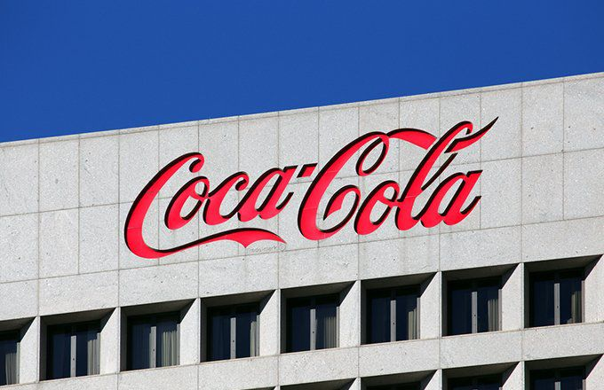The American Asa Griggs Chandler established this global firm on May 8, 1886. Prominent ones of the Coca-Cola brand include the Coke, Fanta, diet Coke, and Sprite brands. The most notable brands that Coca-Cola has purchased to extend its empire. In furthermore, the company has the appropriate licencing to export all of its beverages to any market in the world (Brondoni, 2019).

Figure 1 - Company of Coca Cola

According to estimates, COCA-COLA sells over 1.3 billion drinks per day, making it the indisputable market leader in the soft drink sector. The monogram, which is red and white, is a symbol of beauty and uniqueness as well as a distinctive badge of international recognition. From its base in Atlanta, the world may purchase such well-known drinks as Coke, Sprite, Diet Coke, as well as the delicious, sweet Fanta. Since the firm manufactures and sells a wide selection of non-alcoholic beverages, it has built a sizable distribution network that allows it to sell its products in over 200 countries. The first medicines and remedies for dyspepsia were developed and produced by Dr. John S. Pemberton, who started a chemical laboratory in 1885. The finished product was stimulating, refreshing, and helpful for stomach difficulties (Bekimbetova et al., 2021).

Until 1888, when an American businessman called Asa Griggs candler purchased the Coca-Cola recipe from an Atlanta pharmacist, the world-famous soft drink had not been produced commercially. Thus, Chandler's professionalism and strategic methods may be directly ascribed to Coca-success Cola's in the 20th century soft-drinks business. A novel substance was produced when pharmacist John Pemberton prepared a caramel-colored liquid as well as brought it to the Pharmacy of Jacob, where it was combined with carbon dioxide-containing water. In addition, the company surveyed customers by handing them free samples of the beverage, and the responses revealed that everyone was pleased with the purchase. During 1888 and 1891, Coca-Cola produced a billion gallons of caramel syrup after inventing the process. President of the Coca-Cola Company and wealthy businessman Asa Griggs Candler holds share options worth $2,300. (Nair et al. 2021)

Joseph Pemberton, a prosperous businessman from Mississippi, was responsible for bottling Coca-Cola and making it widely available by 1894. Candler built up sugar refineries in Chicago in 1895, Dallas in 1899, and Los Angeles in 1901. Robert Woodruff, a renowned marketing expert, always sought out new and exciting ventures. In 1928, the firm flourished because to his careful planning and execution, allowing it to enter new foreign markets. After Robert began promoting Coca-Cola during the 1919 Olympic Games, the company quickly became a key sponsor. After America joined the war in 1941, thousands of citizens were called up for overseas duty. These actions are in tribute to the brave pioneers who came before us. The chairman of the Coca-Cola Company, Robert Woodruff, announced that anybody in uniform would get a free bottle of Coke. While at Coca-Cola, one of Goizueta's undertakings was the development of a new flavour for the beverage, the first such modification to the drink's composition in 99 years. In 1993, as Coca-marketing Cola's campaigns first got rolling, the world was introduced to the iconic Polar Bear. Low- and no-calorie soft drinks, Coke Zero as well as PowerAde Zero, were added to the Coca-Cola lineup in 2008 (Serôdio et al., 2018).

## Competitors of COCA-COLA

Table 1 - Competitor Analysis of Coca Cola

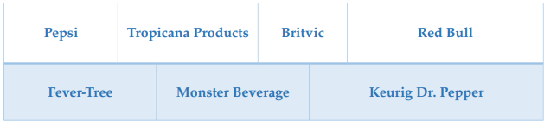

## PESTLE Analysis of Coca Cola

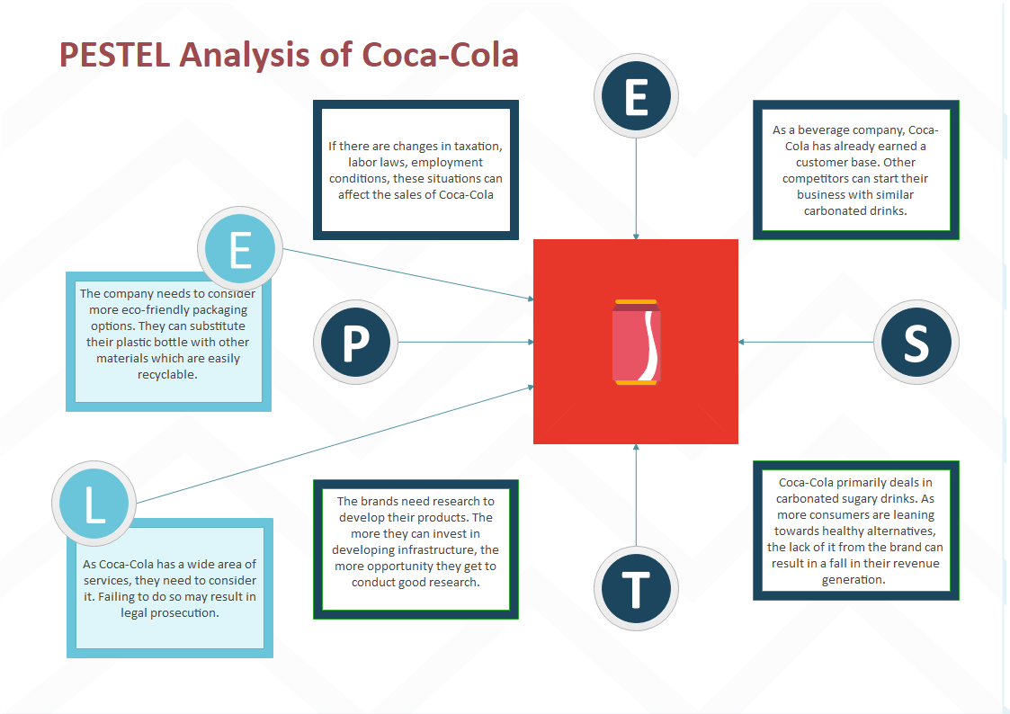

Figure 2 - Pestle Analysis of Coca Cola

## SWOT Analysis of Coca Cola

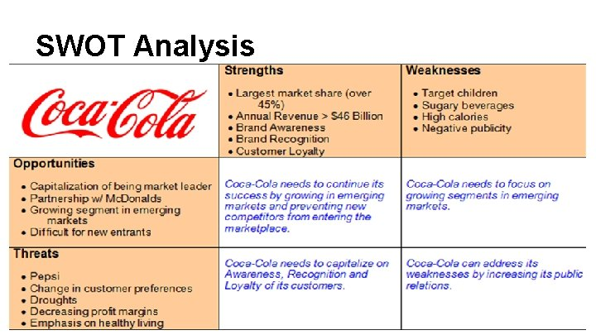

Figure 3 - SWOT Analysis of Coca Cola

# International Operations Management of Coca Cola

Minimizing foreign hazards, maintaining compliance in far-flung areas, and collaborating with international partners are all tasks that may be aided by management of international operations (IOM). The information presented here may be used to improve the administration of any operation whose goal is to convert inputs into products or services. Creating products, managing assets, and satisfying customer needs are the three main functions of every enterprise. Management of operations includes banking, enterprises, customers, and suppliers, as well as technology advancements. Corporate operations serve as a connecting link between the supply chain, finance, human resources, and marketing. Managing a company's operations requires both cutting-edge innovation and time-tested service models (Stuckler et al., 2018).

Operational managers at The Coca-Cola Company are held accountable for the quality of the company's output and the effectiveness with which it puts its resources to use. Decisions in the realm of operational management arise in a wide variety of settings, including but not limited to planning, production, consumption, and distribution. There are both tactical and operational aspects to managing operations. Maps of the supply chain and digital recreations of actual manufacturing facilities are two examples of such strategic tools. Examples of such practical problems include plant architecture, project management style, equipment choosing, and equipment replacement. Production and schedule planning and control, inventory and quality assurance, traffic and product inspection, material handling and inspection, industrial equipment maintenance policies, an operations management framework, and the launch of new product lines are all examples of what we mean by "operations"(Lee and Tang, 2018).

Figure 4 : Operation Management in Coca Cola Company

## Information flow

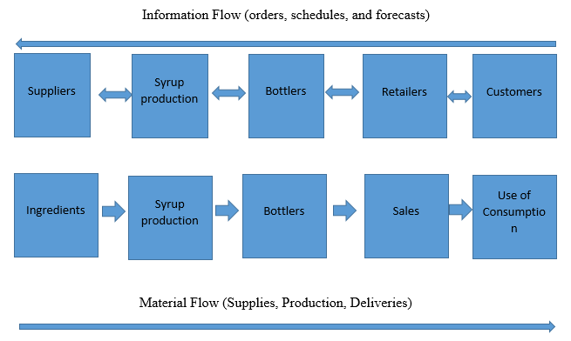

## Manufacturing process

Coca-Cola has a global infrastructure of manufacturing and bottling plants. Considering their status as the world's biggest beverage manufacturer, this is an essential aspect of their everyday operations that boosts morale significantly.

## Production Systems

Some examples of these inputs are chemicals, vanilla beans, kola nuts, sweeteners, cans, cartons, workers, utilities, equipment, manufacturing, merchants, stores, and so on. Beverages as well as cold drinks may be made from the raw materials throughout the conversion process.

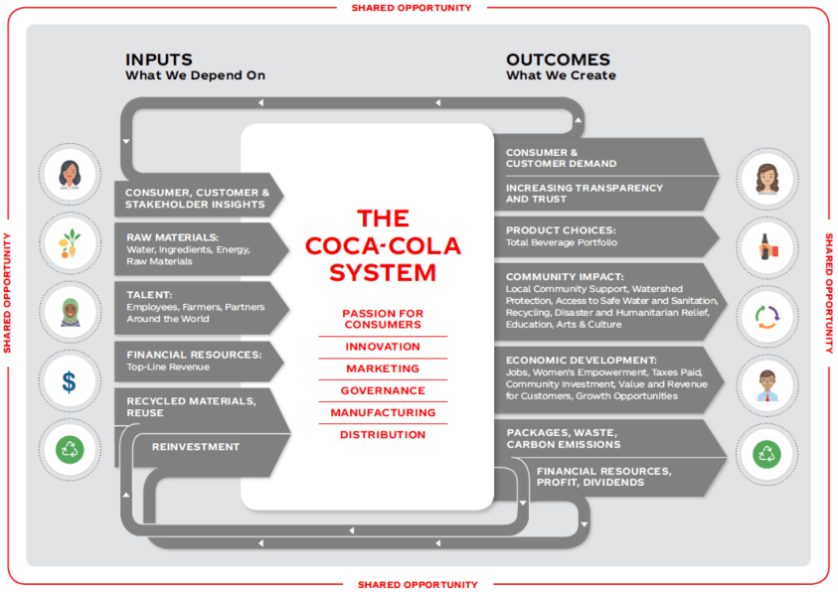

Figure 5 - Production System of Coca Cola

## Products

A selection of cold drinks, with an emphasis on satisfied customers. Beans from the vanilla orchid, oils infused with essence and perfumes, caffeine nuts, and sweeteners are only some of the primary ingredients. It's likely that the heaviest components, which are crucial to the final quality of high-end goods, are only now being mixed with distilled water. Final product assembly includes delivering drinks to parking structures. To avoid tampering with the drink's contents, Coca-Cola bottles must be protected from damage while being transported to the shop for packaging. Machines move and store Coke cans and bottles, so before they are sent to shops and markets, it is crucial that the packaging is safe (Singaram et al., 2019).

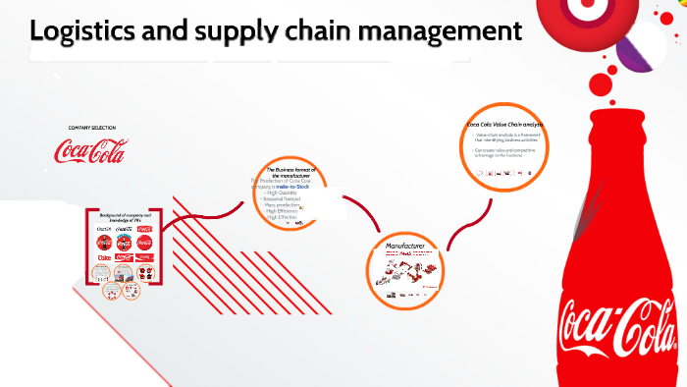

Figure 6 - Product process

## Total Quality Management (TQM)

In order to achieve long-term, significant success, a more customer-centric management strategy is required. Quality assurance for goods, services, and organisational culture in an operational workplace can only be improved with the active participation of all team members in this sort of approach. All manufacturing processes must adhere to the same set of criteria if Coke is to maintain its high quality. It would ensure the highest standards of product quality, as well as the security and well-being of customers. When it comes to safety as well as product quality, Coca-Cola is a global leader in implementing TCCMS standards throughout all of its locations (Lee and Tang, 2018).

## Management of Coca Cola Inventory units:

The business operation is equipped with a number of vending machines. Instead than relying on manual counting, which would be time-consuming and labor-intensive, modern inventories employ bar code software. The company's mainframe computer system often contains information on every automated machine, including its current status, where it is located, and what category it falls under. Track It is the brand new system. This specialist programme gathers information about the business and transmits it to scanning terminals (Lee and Tang, 2018).

## Coca Cola Supply chain

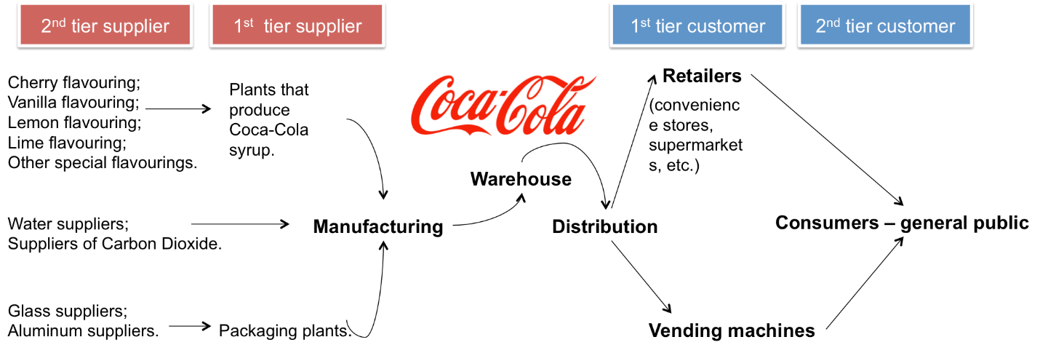

Figure 7 - Coca Cola Supply chain

# Culture of creativity and innovation in Coca Cola

Everything that Coca-Cola produces revolves on the idea of innovation. This is the reason they use eco-friendly materials for their packaging and energy-efficient fridges. Coke's innovative marketing strategies are successful because of their constant pursuit of new ways to reach and engage with people all over the globe. Their hunger for achievement is fed by their capacity for innovation (Tran, 2021).

In today's competitive corporate environment, innovation and change are crucial. When it comes to producing concentrates, syrups, or soft drinks, Coca-Cola is unrivalled. The ideas that guide the company's development in a sustainable manner have always included the company's strong marketing tactics and innovations. However, several processes still need to be improved in order to reduce sugar content, as customers increasingly prioritise leading healthier lifestyles. In particular, they need to lessen their reliance on plastic bottles to diversify their product offerings.

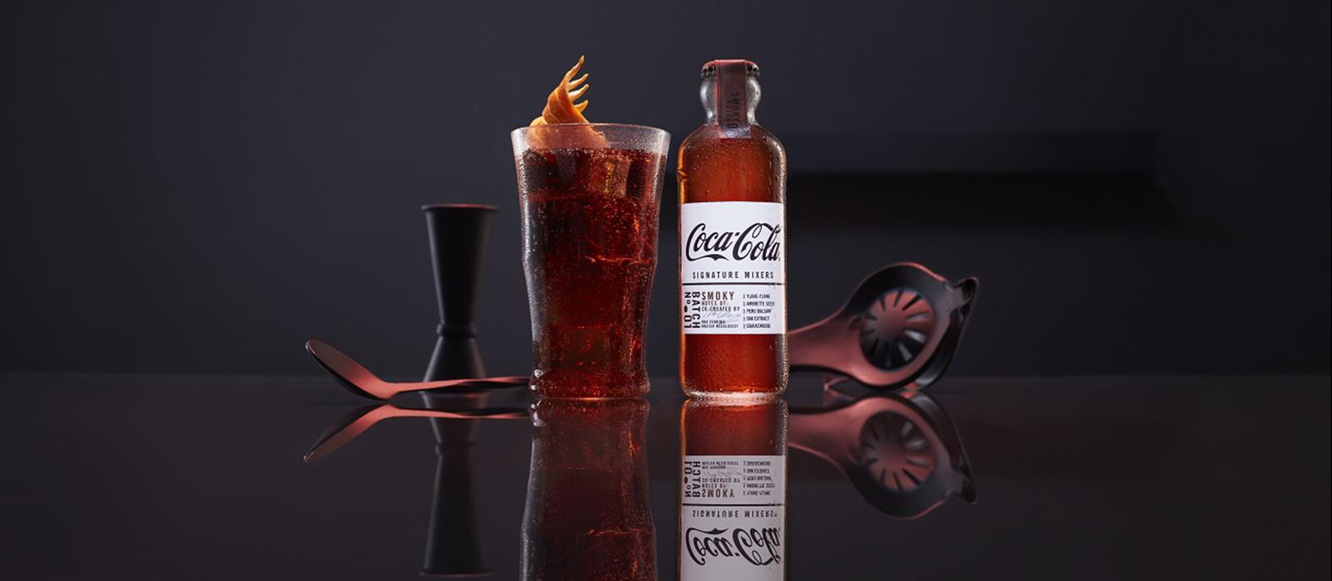

Figure 8 - Innovation in Coca Cola

The modern market is in a constant state of flux. Any successful business must be in sync with its customers. Customers are prone to boredom and often seek for novel goods. A corporation has to develop new goods or services in order to keep up with the ever-changing preferences and requirements of its clientele. Coca-Cola developed C2, a low-carb soft drink, to respond to consumer demand. This happened because of people's interest in low-carb diets and the needs of the market. In addition, they plan to distribute a new soda named Coca-Cola Zero. Calorie-wise, this soft drink has none. Coca-Cola always has recognised the need to innovate and has worked hard to provide new products to the market. Coke is available in several other flavours, including lime, lemon, vanilla, and cherry. Shortly, Coke will be available in a new flavour: raspberry. They want to use Splenda, a sugar alternative that is suitable for diabetics, to sweeten Diet Coke as well (Gehani, 2016).

## Process of innovation and policy structure adopted in Coca Cola

### **Bottling Innovation**

The efficiency of the Coca-Cola bottling system is among the company's many strengths. It paves the way for them to operate internationally whilst keeping their focus on regional needs. When it comes to bottling, the corporation only works with local companies who have a significant impact on the economy and are heavily involved in charitable and other community-oriented endeavours. Thanks to this forward-thinking management strategy, Coca-Cola is able to reap the benefits of economies of scale via the efficient management of a widespread franchise arrangement for its bottling operations.

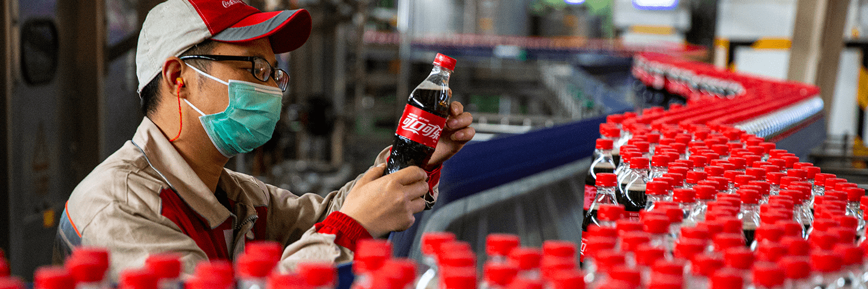

Figure 9 - Bottling innovation in Coca Cola

### **Vending Innovation**

With the advent of the open-top metal coolers, automated refrigerator vending machines became a common sight. The latest generation of eco-friendly coolers today really helps the environment by reducing carbon dioxide emissions. Direct Carbon dioxide equivalents greenhouse gas emissions may be reduced by around 99% when a CO2 refrigeration system as well as HFC-free insulating foam are used (Chu, 2020).

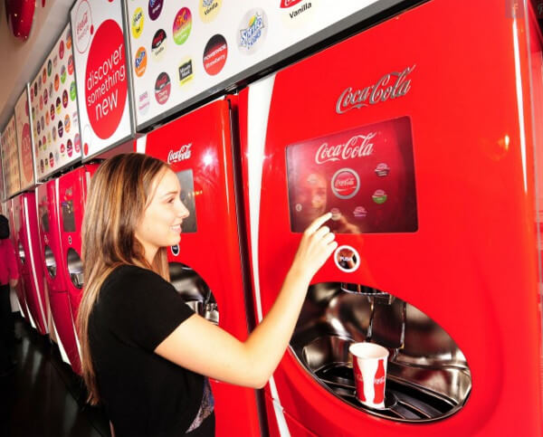

Figure 10 - Vending Innovation in Coca Cola

### **less carbohydrate containing drink**

The firm has created C2, a low-carb beverage, to better serve its worldwide clientele. This item was introduced to meet the low-carb needs of consumers. Taking into account the most crucial aspect, this is undoubtedly originality. There are currently available on the market Coke combinations such as Coke flavoured with lime, Vanilla, or cherry essence. The firm is working toward releasing a Coke product sweetened with Splenda, the most diabetes-friendly sugar alternative (Chu, 2020).

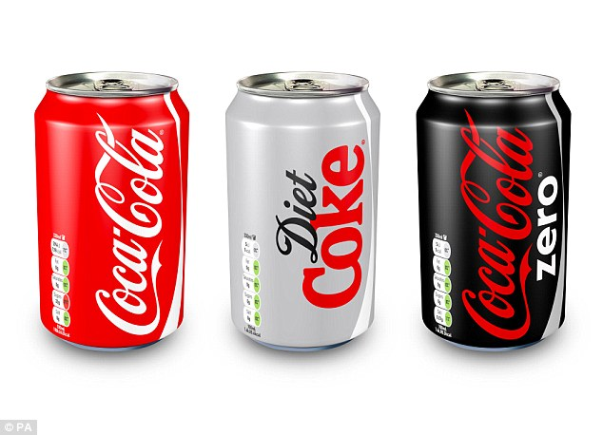

Figure 11 - Diet Coca Cola

## Internally and externally innovative factors for Coca-Cola

The planned management function inside every firm is affected by both internal and external factors; Coca-Cola is no exception. Coca-Cola is a popular choice for quenching thirst in many parts of the globe. Coca-Cola is not only the most well-known product around the world, but also the best-selling beverage of all time.

Coca-ability Cola's to carry out its managerial role of planning is, like any other company's, subject to a wide range of internal and external influences. Each day, people all across the globe drink and over a billion glasses of Coca-Cola to quench their thirst. Coca-Cola is the most recognised brand in the world and has been the best-selling soft drink of all time. An estimated 398 million people live in areas where the Coca-Cola franchise is active. Roughly 72,000 people are employed by Coca-Cola Enterprises, and the company manages 463 locations, 54,000 vehicles, and approximately 2.4 million beverage vending machines, dispensers, as well as coolers (Chua et al., 2020).

# International Operations Management Issues in Coca Cola Company

## Industry shifts

Since all nonalcoholic manufacturing are often significantly influenced by the aforementioned factors—consumer health, requirements, and preferences—the company must increase the variety of products it offers as well as the pricing at which those products sell in the market. Conversely, the presence of intermediates in many nations has a significant detrimental impact on the coke business, making Coca-Cola less adaptable to the rapidly evolving industrial setting of the beverage industry (Jones and Comfort, 2018).

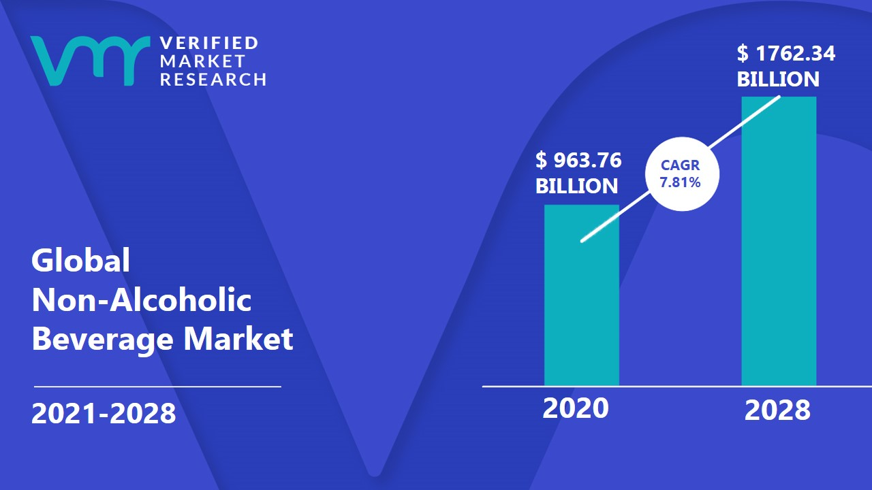

**Figure 12 - Non-Alcoholic Beverage Market Size, Share, Opportunities & Forecast**

Coke bottling partners mostly operate via trucks and transportation systems such as cars. They often require a large amount of gas and energy. As a result of the increasing cost of production components, the increase in the fuel process would result in a decrease in profitability. Government representatives are frequently worried about health-related issues, which may affect demand for coke. Because of the deceptive nature of the activities, multiple contracts to sell refreshment drinks at various schools are carried out. Coca-Cola drinkers are fully aware of such difficulties, and poor media promotion may cause beverage sales to plummet as a result.

Drinks with no alcohol are significantly more competitive all around the world. Coca-Cola competes on an international as well as a local level. In the United States, Pepsi is operating as a rival. Coca-Cola already has the ability to sustain market share and optimise profit levels on a worldwide scale (Tran, 2021).

The weather has a big impact on soft drink sales all around the world. When the temperature is hot, many people around the world choose cold beverages such as juice and zero coke; nevertheless, demand for the product declines significantly in the winter. Seasonal consumption of refreshing drinks is anticipated to be highest in a few places throughout the world, where temperatures frequently remain high throughout the year (Tran, 2021). Implementing sophisticated competitive policies will undoubtedly generate a wide variety of options for firms to attain a leadership position in domestic and international markets while remaining hard to compete with in the sectors of business (Sulistiani et al., 2019).

The modification of the strategic framework of policies, decisions, and plans for operational operations is an important component for the company entity. Significant changes at all levels of management, including senior management and middle management, may result in personnel being eligible to work in the face of a changing environment. The employment of advanced technology in a corporation often results in a reduction in operating expenses, which ultimately leads to an increase in profitability. Occasionally, a company will require advanced technology comparable to that used by similar other companies, because a corporation must utilise technologically advanced systems in order to compete in the market locally or globally (Tran, 2021).

## Water scarcity and poor quality

In case of coca cola company, the water act as a major ingredient to be used in beverages production. Though all around the world it’s a limited resource too. Companies are annually consuming huge amount of water.

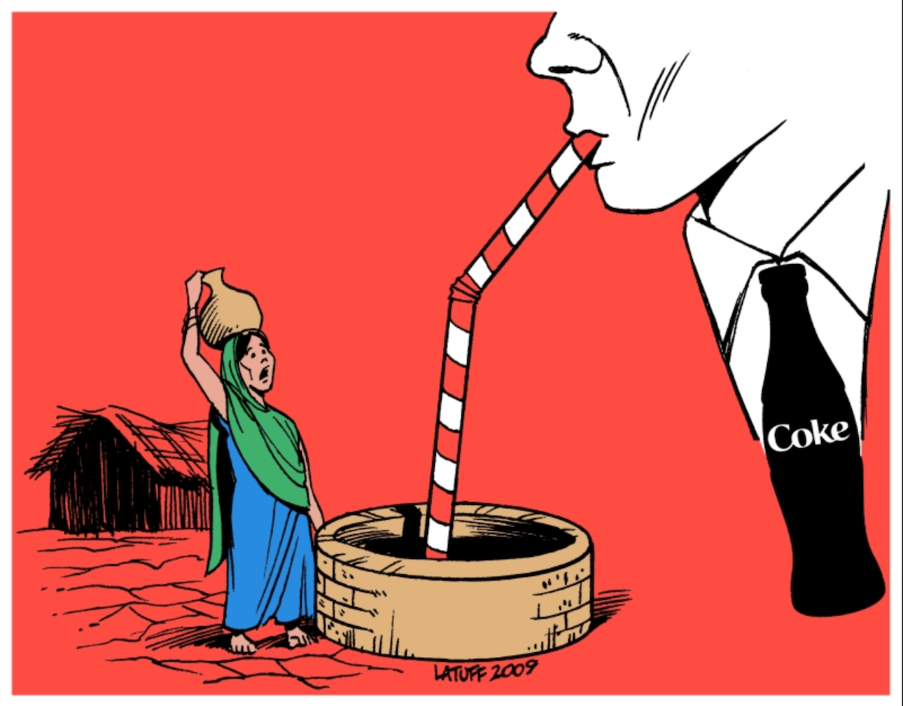

Figure 13 - Water Scarcity Issue

Quality of water is declining demand in this usually increases the production cost of the company which effects the profitability of the organization (Sulistiani et al., 2019). Water sacristy is a major issue in the Coca Cola company, many NGOs are working against the Coca Cola brand to save world water.

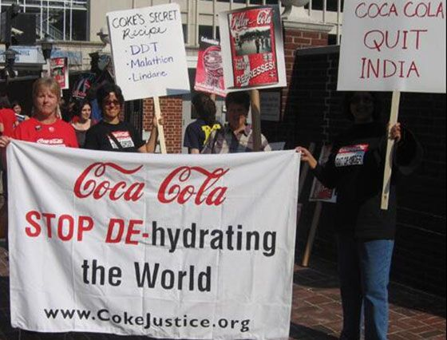

Figure 14 - Protesters Outside Coca-Cola Bottling Plant in India

## Health Issues

More and more people are choosing for healthier lives and thus avoiding items that contain potentially harmful substances. Coca-Cola may see a drop in sales and earnings if consumers shift their preferences to rival companies' healthier offerings in response to the growing awareness of the risks of drinking soda.

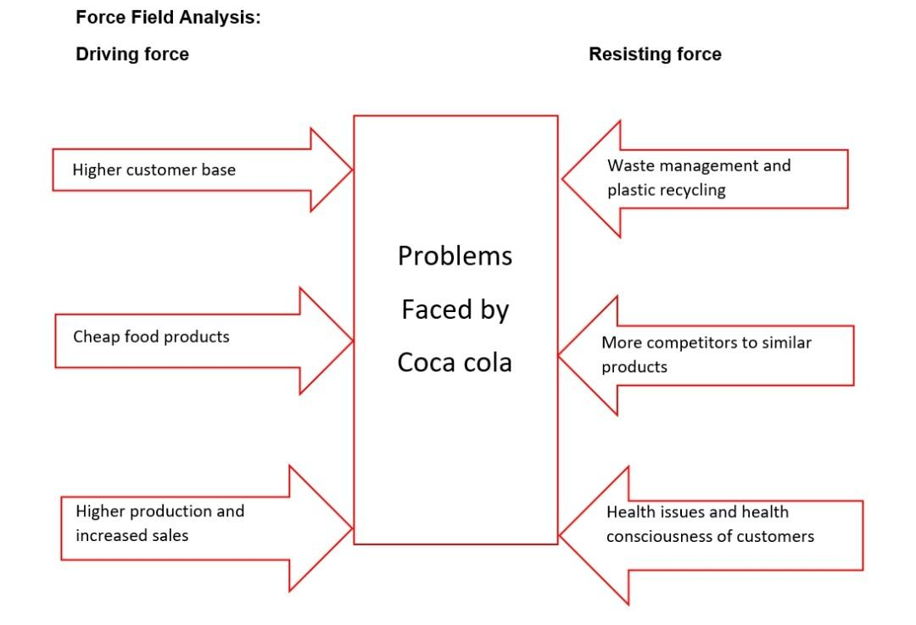

Figure 15 - Health Issues

# Role of innovation in the development of Operations Management techniques

The term "innovation" is used to describe the process through which a business enhances the quality and marketability of its goods and services. Essentially, you'll be expected to suggest new ways of thinking that may be used inside the organisation to boost the standard of their output. A company has to provide novel concepts that will help it expand and gain an edge over rivals if it is to thrive in a highly competitive industry. In contrast to creation, innovation works to improve upon what already exists in the market. Inventions made by others are enhanced by new innovations. The pace of technological development in the last few years has been breathtaking. Invention requires the use of technology. That is to say, technology is a major factor in the emergence of new ideas. On the other side, when a company innovates, it gains an edge over its rivals since it is better able to address the wants of its clientele.

Coca-Cola has maintained a steady stream of new product launches throughout the years. It is able to monitor market tendencies and respond accordingly. For instance, when the firm was criticised for selling goods that were thought to raise the risk of obesity, it responded by releasing Coke Zero, a sugar-free drink that lowers that risk. So doing helped it keep its competitive edge and market dominance. The corporation is also cognizant of the fact that people of various cultural backgrounds have varying tastes when it comes to soft drink flavours, and it has been able to accommodate these needs. Coca-foreign Cola's expansion throughout the years has relied heavily on this approach, and with good reason (Gaither, and Austin, 2016).

# Diverse and Action Plan for Innovation of Operations Management

The chief executive officer (CEO) is the highest-ranking executive in an organisation, responsible for setting the company's direction and implementing its policies, as well as overseeing the company's day-to-day operations and allocating its resources. In addition, this officer is responsible for public relations and serves as a link between the board, middle management, and the rest of the organisation. Thus, the CEO should exhibit behaviour indicative of a commitment for the efficient and effective use of scarce financial, operational, as well as business resources in the service of achieving set objectives.

## Innovative Technological Advancement

Innovation in the business world is a hub of action, and this often involves pooling resources of different types. In addition, for the purpose of accomplishments, goods, and needs, the varied viewpoints of teams with varying levels of education and professional experience are also taken into account.

## Distinctive Packaging

Coke's revolutionary bottle design was conceived with the goal of setting the brand apart from its rivals in both the international and domestic markets. The first bottles using the design were released by the business in 2000. Furthermore, glass bottles are made to provide significant enhancement, resilience, cost reduction, as well as weight reduction. The developed glass bottles are 40% stronger than standard glass soda bottles, 20% lighter, and 10% less expensive (Gaither, and Austin, 2016).

## Well-designed portable bottling system

Coca-distribution Cola's network is one of the most robust in the world. This motivates companies to increase their presence in foreign markets. All of a company's bottling partners are locally based establishments that not only actively contribute to charitable causes but also have a significant influence on the local economy. Using a franchising model for its bottling operations, the company is able to produce at a big scale and achieve economies of scale, exemplifying the successful and creative measures it has taken.

## Vending Innovation

contraption for dispensing food and drinks that resembles a refrigerator but is really an automatic cooler with a metal lid. There are newer models of climate-friendly coolers available now that greatly cut down on carbon dioxide emissions. In order to eliminate 99 percent of greenhouse gas emissions, using a carbon dioxide refrigeration unit and free HFC insulating foam is essential (Odukah, 2016).

# Group Discussion

## Coca Cola and Sustainability

Coca-Cola is focused on sustainability (e.g. water sustainability, carbon footprints reduction, sustainable packaging etc). This has become a priority for our businesses and communities due to the interconnected global challenges of packaging waste and climate change. Its organisation, as well as our bottling partners, are looking at our packaging and considering how we might make changes. Coca-sustainable Cola's packaging plan aims to create progressive change for our packaging by establishing a circular economy - from the design and manufacture of bottles and cans to how they are recycled and reused. Coca-Cola has a responsibility to help address the global plastic waste problem, and we're using our scale and reach across markets to fulfil our long-term business goals, reduce trash pollution, and reduce our carbon footprint.

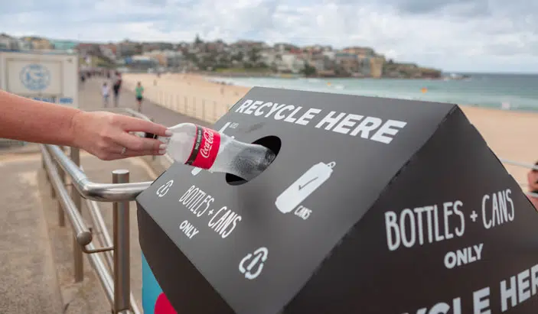

## Recycling Process

Coca-Cola strives to recover and recycle one bottle or can for every one sold, and we work hard to make all of our packaging recyclable. We established a goal of reducing our carbon dioxide emissions by 25% by 2030 beginning in 2015. Regardless of size, shape, or composition, our goal is to collect and recycle every bottle or can sold. Our organisation prioritises sustainable business and environmental, social, and governance (ESG) issues as a critical component in how we do business and construct our corporate strategy. It is also crucial in terms of how we grow and report on our operations and attempts to become more sustainable.

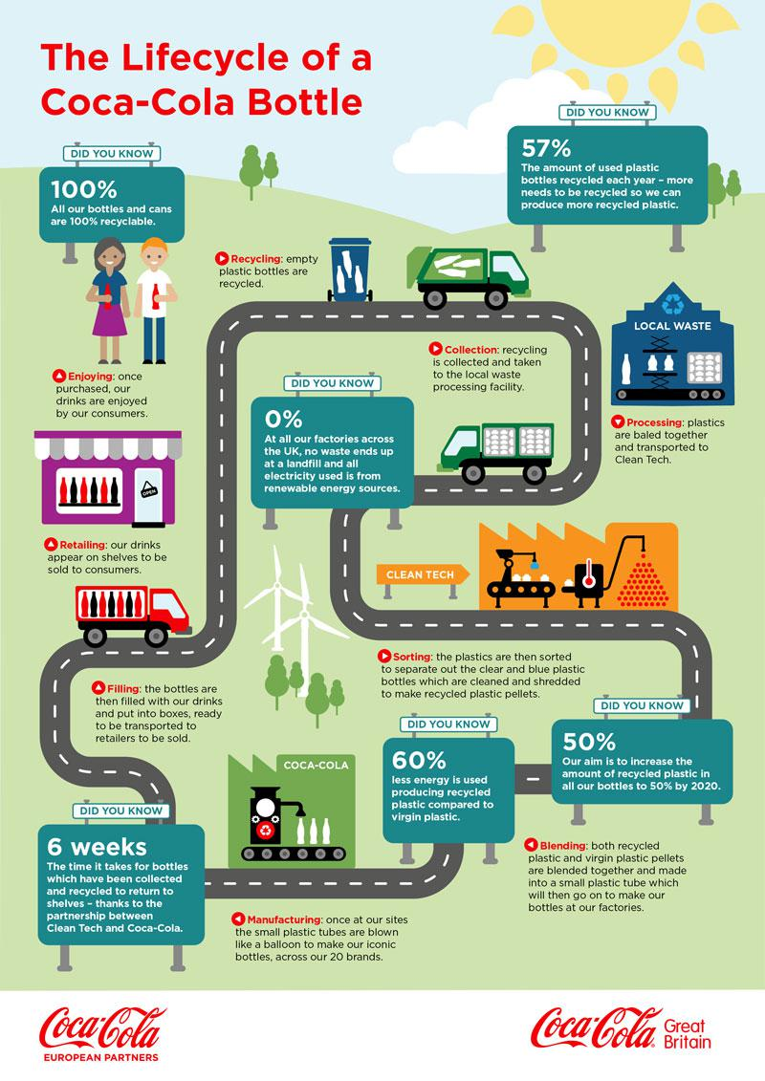

# Conclusion & Recommendations

Management may need to take an active role in raising productivity by seeking scale economies and making full use of available resources in order to ensure the highest possible product quality in order to run a company effectively. Minimizing the potential for material waste and aiding in the selection of low-cost, high-quality materials for efficient production are both outcomes of careful management consideration of the system, analysis, cost control, as well as status of effective production (Graham, 2020).

## Recommendations

The organisation should make an effort to show its workers appreciation and motivation on a regular basis so that its goals may be met. If the Coca-Cola business wants to increase production, it must consider implementing new restrictions for staff. Furthermore, a reward system may take the shape of money or something else entirely. The corporation accepts full responsibility for how it treats its employees and must treat all of its workers fairly. Employee evaluation schemes should be well-thought-out and comprised of things that are really useful to the workers. In addition, it's important to provide staff training sessions on a regular basis so that workers may develop and hone their abilities in ways that benefit the company as a whole.

# References

Bekimbetova, G.M., Erkinov, S.B. and Rakhimov, U.F., 2021. CULTURE AND ITS INFLUENCE ON CONSUMER BEHAVIOR IN THE CONTEXT OF MARKETING (in case of “Coca-Cola” company). *Deutsche Internationale Zeitschrift für zeitgenössische Wissenschaft*, (7-2), pp.4-6.

Brondoni, S.M., 2019. Shareowners, stakeholders & the global oversize economy. The coca-cola company case. *Symphonya. Emerging Issues in Management*, (1), pp.16-27.

Chu, B., 2020, November. Analysis on the Success of Coca-Cola Marketing Strategy. In *2020 2nd International Conference on Economic Management and Cultural Industry (ICEMCI 2020)* (pp. 96-100). Atlantis Press.

Chua, J.Y., Kee, D.M.H., Alhamlan, H.A., Lim, P.Y., Lim, Q.Y., Lim, X.Y. and Singh, N., 2020. Challenges and solutions: A case study of Coca-Cola company. *Journal of the Community Development in Asia (JCDA)*, *3*(2), pp.43-54.

Gaither, B.M. and Austin, L., 2016. Campaign and corporate goals in conflict: Exploring company-issue congruence through a content analysis of Coca-Cola’s Twitter feed. *Public Relations Review*, *42*(4), pp.698-709.

Gehani, R.R., 2016. Corporate brand value shifting from identity to innovation capability: from Coca-Cola to Apple. *Journal of technology management & innovation*, *11*(3), pp.11-20.

Jones, P. and Comfort, D., 2018. The coca cola brand and sustainability. *Indonesian Journal of Applied Business and Economic Research*, *1*(1), pp.34-46.

Lee, H.L. and Tang, C.S., 2018. Socially and environmentally responsible value chain innovations: New operations management research opportunities. *Management Science*, *64*(3), pp.983-996.

Nair, R.K., Reddy, L.S., Verma, P., Pandey, R., Yuwono, S., Sin, L.G., Qi, W.Y., Kee, D.M.H., Gee, O.X., Ing, T.W.S. and Yu, T.P., 2021. The impact of COVID 19 towards international business strategy: A study of Coca-Cola company. *International Journal of Accounting & Finance in Asia Pasific (IJAFAP)*, *4*(2), pp.73-92.

Odukah, M.E., 2016. Factors influencing staff motivation among employees: A Case study of equator bottlers (Coca Cola) Kenya. *Journal of Human Resource and Sustainability Studies*, *4*(02), p.68.

Serôdio, P.M., McKee, M. and Stuckler, D., 2018. Coca-Cola–a model of transparency in research partnerships? A network analysis of Coca-Cola’s research funding (2008–2016). *Public health nutrition*, *21*(9), pp.1594-1607.

Singaram, R., Ramasubramani, A., Mehta, A. and Arora, P., 2019. Coca Cola: A study on the marketing strategies for millenniums focusing on India. *International Journal of Advanced Research and Development*, *4*(1), pp.62-68.

Stuckler, D., Ruskin, G. and McKee, M., 2018. Complexity and conflicts of interest statements: a case-study of emails exchanged between Coca-Cola and the principal investigators of the International Study of Childhood Obesity, Lifestyle and the Environment (ISCOLE). *Journal of public health policy*, *39*(1), pp.49-56.

Sulistiani, H., Wardani, F. and Sulistyawati, A., 2019, October. Application of Best First Search Method to Search Nearest Business Partner Location (Case Study: PT Coca Cola Amatil Indonesia, Bandar Lampung). In *2019 International Conference on Computer Science, Information Technology, and Electrical Engineering (ICOMITEE)* (pp. 102-106). IEEE.

Tran, V.T., 2021. Exhibiting Coca-Cola at universal exhibitions. *Food, Culture & Society*, *24*(2), pp.269-290.

Tran, V.T., 2021. Exhibiting Coca-Cola at universal exhibitions. *Food, Culture & Society*, *24*(2), pp.269-290.

|  |  |  |
| --- | --- | --- |
| **Assessment Coversheet and Feedback Form** | **Faculty of Business, Law and Social Sciences**  School of Business | New Logo Tiny |

Complete the details marked in the **coloured text** and leave everything else blank. Where appropriate, copy and paste your submission after the first pages as indicated. You are reminded of the University regulations on cheating. Except where the assessment is group-based, the final piece of work which is submitted must be your own work. Close similarity between submissions is likely to lead to an investigation for cheating. You must submit a file in an MSWord or equivalent format as tutors will use MSWord to provide feedback including, where appropriate, annotations in the text.

|  |  |  |  |
| --- | --- | --- | --- |
| **Student Name** | Faraz Anwar | **Reasonable Adjustments** |  |
| **Student Number** | 21183719 | Check this box [x] if the Faculty has notified you that you are eligible for a Reasonable Adjustment (including additional time) in relation to the marking of this assessment. Please note that action may be taken under the University’s Student Disciplinary Procedure against any student making a false claim for Reasonable Adjustments. | |
| **Course and Year** | MSc Management and International Business |
| **Module Code** | BUS7079 |
| **Module Title** | International Operations Strategy and Innovation |
| **Module Tutor** | Umer Asif |
| **Personal Tutor** | Rachel Mason |

|  |  |  |  |  |  |
| --- | --- | --- | --- | --- | --- |
| **First Marker Name:** |  | **First Marker Signature:** |  | **Date:** |  |
| **Feedback:** General comments on the quality of the work, its successes and where it could be improved | | | | | |
|  | | | | **Provisional Uncapped Mark** Marks will be capped if this was a late submission or resit assessment and may be moderated up or down by the examination board. | |
| % | |
| **Feed Forward:** How to apply the feedback to future submissions | | | | | |
|  | | | | | |

|  |  |  |  |  |  |
| --- | --- | --- | --- | --- | --- |
| **Quality and use of Standard English and Academic Conventions** | | | | | |
|  | Spelling Errors |  | Style is Colloquial |  | **Standard is a Cause for Concern** |
|  | Grammatical Errors |  | Inappropriate Structure | If the box above has been ticked you should arrange a consultation with a member of staff from the Centre for Academic Success via [Success@bcu.ac.uk](mailto:Success@bcu.ac.uk) | |
|  | Punctuation Errors |  | Inadequate Referencing |

|  |  |  |  |  |  |
| --- | --- | --- | --- | --- | --- |
| **Moderation Comments** (Please note that moderation is carried out through ‘sampling’. If this section is left blank, your work is not part of the sample.) | | | | | |
| Moderation is done via sampling. Your work was not part of the sample. | | | | | |
| **Moderator Name:** |  | **Moderator Signature:** |  | **Date:** |  |